**Rockbuster Stealth Data Analysis Project**

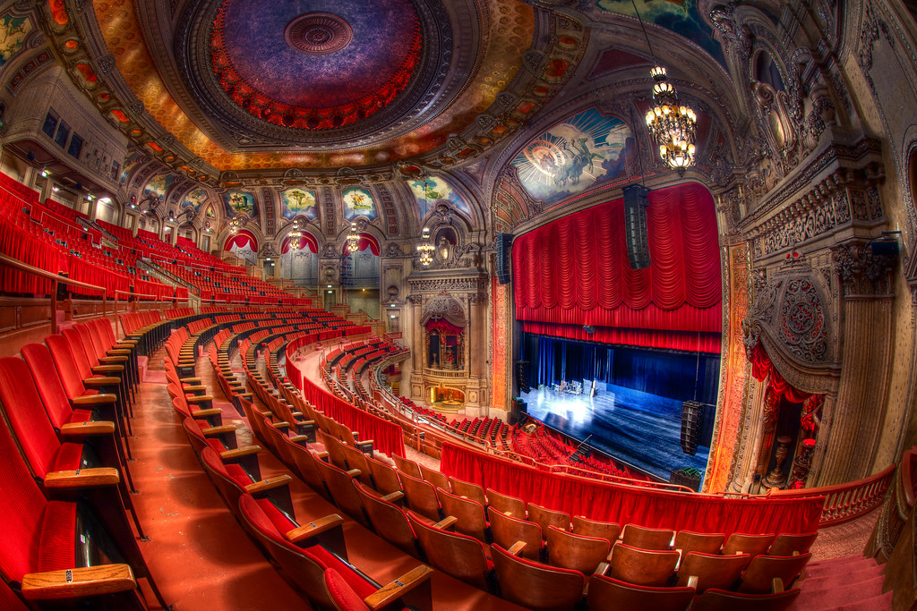

**Introduction**

Rockbuster Stealth LLC is a movie rental company that used to have stores around the world. Facing stiff competition from streaming services such as Netflix and Amazon Prime, the Rockbuster Stealth management team is planning to use its existing movie licenses to launch an online video rental service in order to stay competitive.

**Key Questions and Objectives:**

The Rockbuster Stealth Management Board has asked a series of business questions and they expect data-driven answers that they can use for their 2020 company strategy.

**Here are the main questions:**

* Which movies contributed the most/least to revenue gain?
* What was the average rental duration for all videos?
* Which countries are Rockbuster customers based in?
* Where are customers with a high lifetime value based?
* Do sales figures vary between geographic regions?

**I would like to answer above questions in upcoming slides as Project Deliverables**

**Project Deliverables**

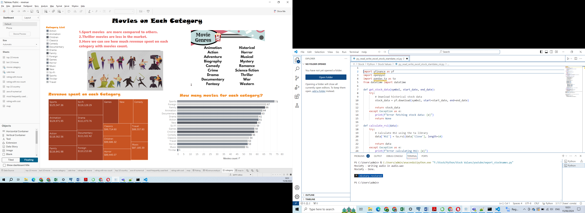

**Which movies contributed the most/least to revenue gain? And Do sales figures vary between geographic regions?**

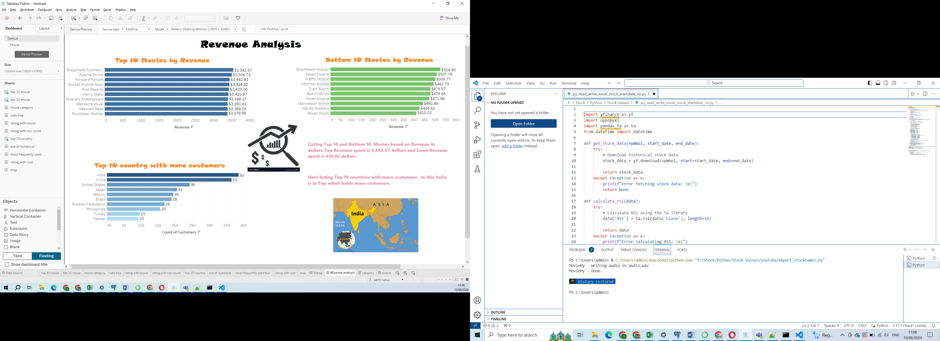

**Which countries are Rockbuster customers based in?**

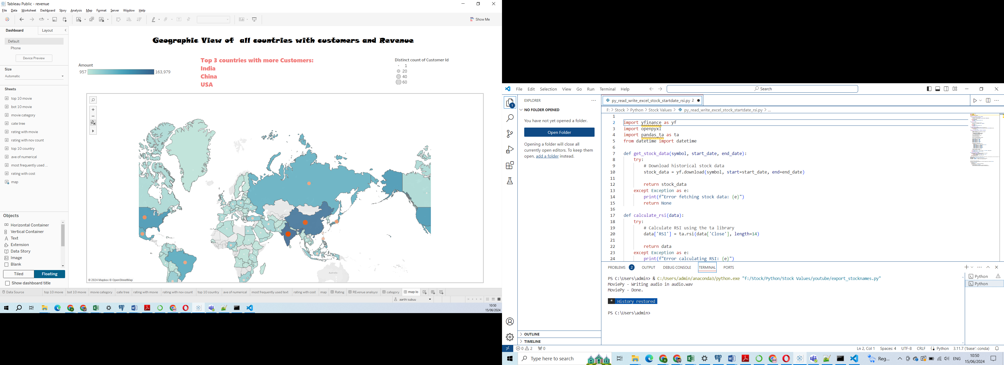

**What was the average rental duration for all videos?**

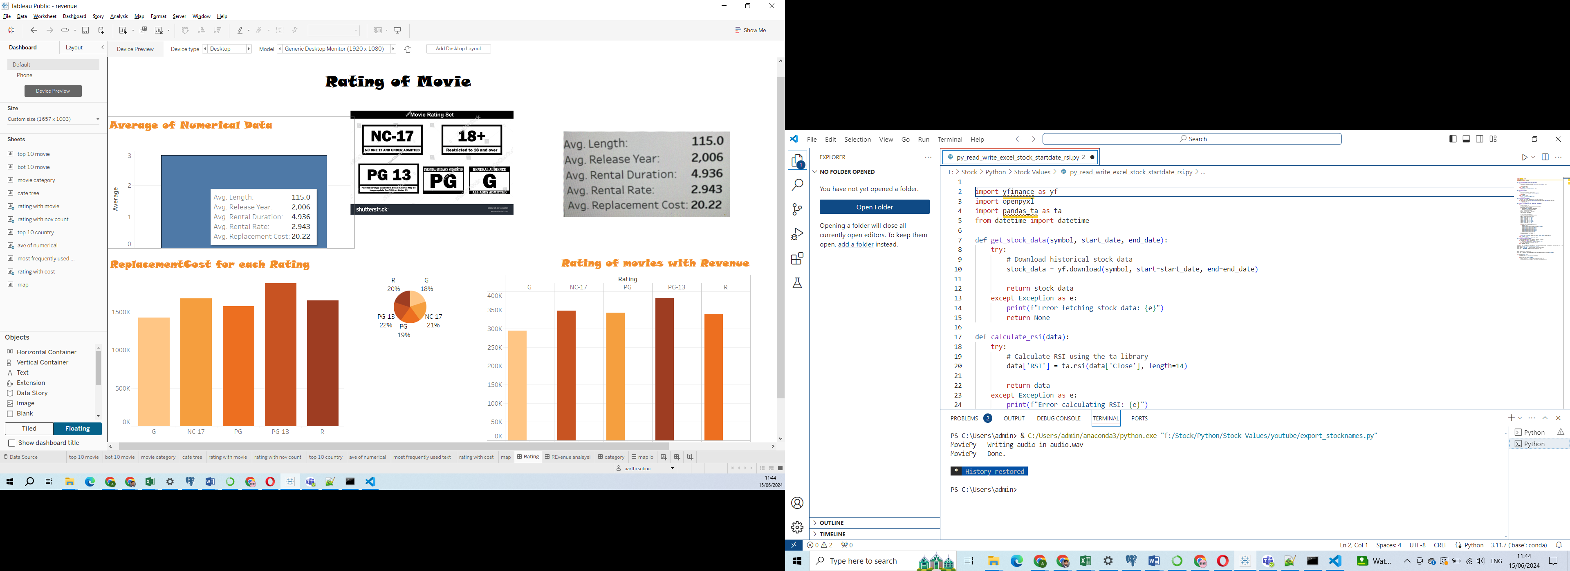

**Summary statistics:**

*Average Replacement cost is 20.2*

*Average Release Year is 2006*

*Average Rental rate is 2.9*

*Average Rental duration is 4.9*

The Least most Genre is Thriller

The Top most Genre is Sports

The Top most Country with More Customers is India

The Most frequently used Rating is PG -13

dfsdfsdfsdfsdfsdf[Sidebar Title]

[Sidebars are great for calling out important points from your text or adding additional info for quick reference, such as a schedule.

They are typically placed on the left, right, top or bottom of the page. But you can easily drag them to any position you prefer.

When you’re ready to add your content, just click here and start typing.]

dfsdfsdfsdfsdfsdf[Sidebar Title]

[Sidebars are great for calling out important points from your text or adding additional info for quick reference, such as a schedule.

They are typically placed on the left, right, top or bottom of the page. But you can easily drag them to any position you prefer.

When you’re ready to add your content, just click here and start typing.]

dfsdfsdfsdfsdfsdf[Sidebar Title]

[Sidebars are great for calling out important points from your text or adding additional info for quick reference, such as a schedule.

They are typically placed on the left, right, top or bottom of the page. But you can easily drag them to any position you prefer.

When you’re ready to add your content, just click here and start typing.]

dfsdfsdfsdfsdfsdf[Sidebar Title]

[Sidebars are great for calling out important points from your text or adding additional info for quick reference, such as a schedule.

They are typically placed on the left, right, top or bottom of the page. But you can easily drag them to any position you prefer.

When you’re ready to add your content, just click here and start typing.]

**Top 10 cities IN Top 10 countries with number of Customers**

|  |  |  |
| --- | --- | --- |
| **City** | **Country** | **Number of Customers** |
| Aurora | United States | 2 |
| Atlixco | Mexico | 1 |
| Xintai | China | 1 |
| Adoni | India | 1 |
| Dhule (Dhulia) | India | 1 |
| Kurashiki | Japan | 1 |
| Pingxiang | China | 1 |
| Sivas | Turkey | 1 |
| Celaya | Mexico | 1 |
| So Leopoldo | Brazil | 1 |



**Thank you**

**For queries**

**Contact :** [**artimysticaldatanalyst@gmail.com**](mailto:artimysticaldatanalyst@gmail.com)

**Tableau Link:** [**link**](https://public.tableau.com/app/profile/aarthi.subuu/viz/Task3_10_17184503458890/Story1?publish=yes)